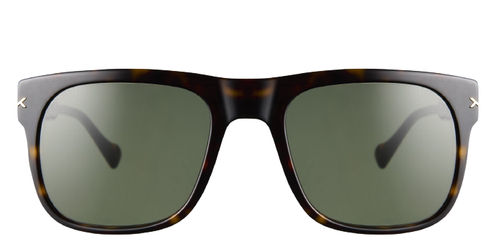 **Bruchay Sun**

**Product Information**

|  |  |
| --- | --- |
| **Brand** | kits |
| **Gender** | unisex |
| **Lenses** | Prescription lenses available |
| **Material** | acetate |

**Description**

**Flaunt your athletic style sensibilities wearing the Bruchay sunglasses. These square full rim glasses come in a bold, statement making shape designed to flatter the face with its striking lines. Constructed in acetate for optimal durability, the frames speak to the wearer who prefers lightweight but sturdy eyewear. For good looking glasses that stand up to a go-go-go life, reach for these distinctive frames from KITS. Please note these frames fit large and are best suited to those with wider faces**

|  |
| --- |
| **What you'll get:**  * **Optical grade sun lenses with 100% UV protection.** * **Soft case and cleaning cloth.** * **Unconditional 30 days return policy.  Free return shipping.** |